**Student Activity Guide: Lab Assignment - For Loops** Name ____________________

Unit 3 Lesson 17

**Directions**

The goal for the lab assignment is to be creative with picture manipulation using the skills and techniques you learned in earlier lessons. Take a photograph to use in the lab, use a photo you already have, or use the image provided in the lesson resources. Use FOR loops to make color changes and other manipulations to the image.

**Sample Project:**

**BEFORE AFTER**

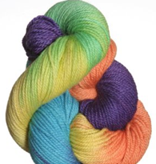 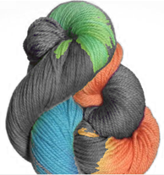

**Requirements:**

* Must make at least three changes to the picture.
* Include:
  + color changes
  + rotations and translations
  + Chroma key compositing